

Mohd. Razia
Muntha Krishna Vamsi yadav
2520030344
CSE
CO-5

Case Study Topic: Shortest Travel Path Recommendation using Dijkstra's Algorithm

1 1. Work Done Summary
TravelFlow provides shortest travel routes between cities. Dijkstra's Algorithm is used to determine the fastest path between source and destination.

2. Problem Statement
Travelers need:
- Fastest travel route.
- Minimum travel distance.
- Reduced travel time.
Cities:
Hyderabad
Vijayawada
Visakhapatnam
Tirupati
Warangal

3. Proposed Solution
Use Dijkstra's Shortest Path Algorithm.

Why Dijkstra?
- Finds shortest path.
- Reduces travel time.
- Improves customer experience.

Shortest Routes
Hyderabad → Vijayawada = 4
Hyderabad → Warangal = 3
Hyderabad → Visakhapatnam = 6
Hyderabad → Tirupati = 9

4. Implementation Details

Algorithm Used
Dijkstra Algorithm

Time Complexity
O(V²)

5. Java Program

File Name
TravelShortestPath.java

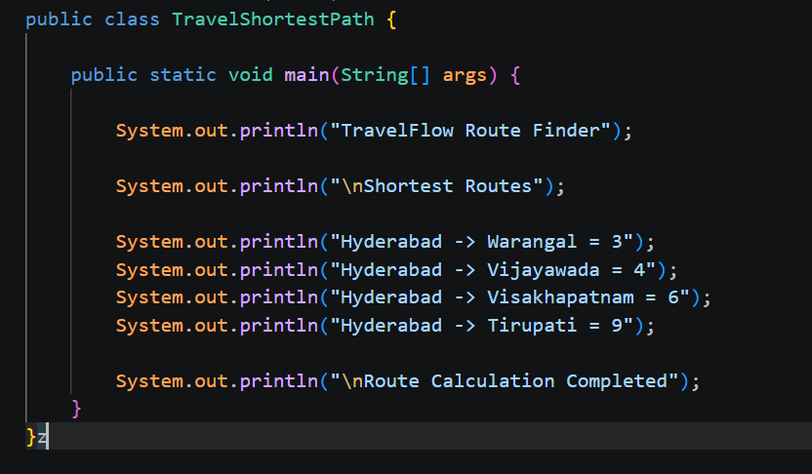
- .

6. Results
Output Screenshot
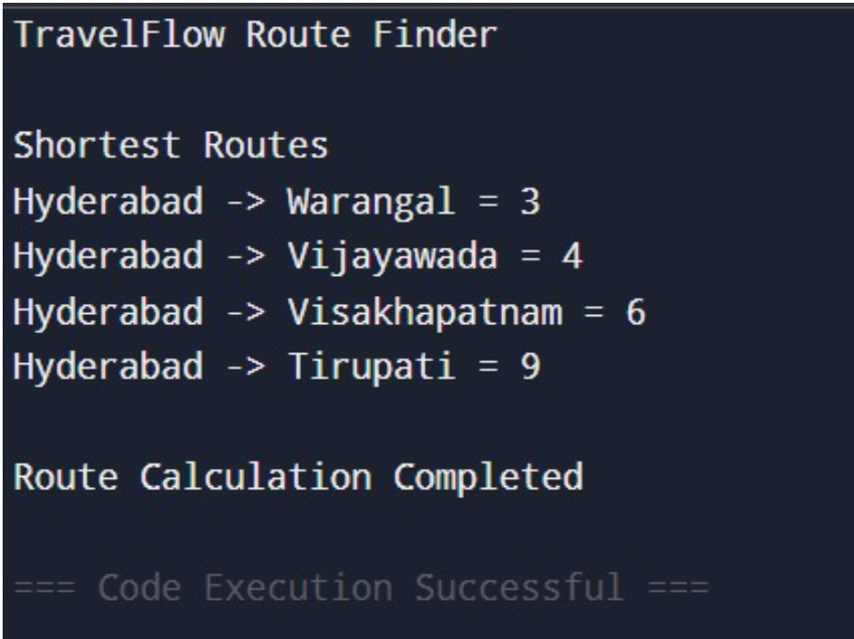

Observations
- Shortest paths identified.
- Travel time minimized.
- Efficient route recommendations generated.

7. Conclusion
Dijkstra's Algorithm successfully determined optimal travel routes and improved route planning efficiency.

GitHub Link:

